**How do I view log files on Linux?**

Open the Terminal or login as root user using ssh command. Go to /var/log directory using the following cd command:  
# cd /var/log

To list files use the following ls command:  
# ls  
Sample outputs from RHEL 6.x server:

anaconda.ifcfg.log boot.log-20111225 cron-20131110.gz maillog-20111218 messages-20131103.gz secure-20131027.gz spooler-20131117.gz up2date-20131117.gz

anaconda.log btmp cron-20131117.gz maillog-20111225 messages-20131110.gz secure-20131103.gz squid uptrack.log

anaconda.program.log btmp-20120101 cups maillog-20120101 messages-20131117.gz secure-20131110.gz swinstall.d uptrack.log.1

anaconda.storage.log btmp-20131101.gz dkms_autoinstaller maillog-20131027.gz mysqld.log secure-20131117.gz tallylog uptrack.log.2

anaconda.syslog collectl dmesg maillog-20131103.gz ntpstats setroubleshoot UcliEvt.log varnish

anaconda.yum.log ConsoleKit dmesg.old maillog-20131110.gz prelink spooler up2date wtmp

arcconfig.xml cron dracut.log maillog-20131117.gz rhsm spooler-20111211 up2date-20111211 yum.log

atop cron-20111211 dracut.log-20120101 messages sa spooler-20111218 up2date-20111218 yum.log-20120101

audit cron-20111218 dracut.log-20130101.gz messages-20111211 secure spooler-20111225 up2date-20111225 yum.log-20130101.gz

boot.log cron-20111225 httpd messages-20111218 secure-20111211 spooler-20120101 up2date-20120101

boot.log-20111204 cron-20120101 lastlog messages-20111225 secure-20111218 spooler-20131027.gz up2date-20131027.gz

boot.log-20111211 cron-20131027.gz maillog messages-20120101 secure-20111225 spooler-20131103.gz up2date-20131103.gz

boot.log-20111218 cron-20131103.gz maillog-20111211 messages-20131027.gz secure-20120101 spooler-20131110.gz up2date-20131110.gz

To view a common log file called /var/log/messages use any one of the following command:  
# less /var/log/messages  
# more -f /var/log/messages  
# cat /var/log/messages  
# tail -f /var/log/messages  
# grep -i error /var/log/messages  
  
Sample outputs:

Jul 17 22:04:25 router dnsprobe[276]: dns query failed

Jul 17 22:04:29 router last message repeated 2 times

Jul 17 22:04:29 router dnsprobe[276]: Primary DNS server Is Down... Switching To Secondary DNS server

Jul 17 22:05:08 router dnsprobe[276]: Switching Back To Primary DNS server

Jul 17 22:26:11 debian -- MARK --

Jul 17 22:46:11 debian -- MARK --

Jul 17 22:47:36 router -- MARK --

Jul 17 22:47:36 router dnsprobe[276]: dns query failed

Jul 17 22:47:38 debian kernel: rtc: lost some interrupts at 1024Hz.

Jun 17 22:47:39 debian kernel: IN=eth0 OUT= MAC=00:0f:ea:91:04:07:00:08:5c:00:00:01:08:00 SRC=61.4.218.24 DST=192.168.1.100 LEN=60 TOS=0x00 PREC=0x00 TTL=46 ID=21599 DF PROTO=TCP SPT=59297 DPT=22 WINDOW=5840 RES=0x00 SYN URGP=0

**Common Linux log files names and usage**

* /var/log/messages : General message and system related stuff
* /var/log/auth.log : Authenication logs
* /var/log/kern.log : Kernel logs
* /var/log/cron.log : Crond logs (cron job)
* /var/log/maillog : Mail server logs
* /var/log/qmail/ : Qmail log directory (more files inside this directory)
* /var/log/httpd/ : Apache access and error logs directory
* /var/log/lighttpd/ : Lighttpd access and error logs directory
* /var/log/boot.log : System boot log
* /var/log/mysqld.log : MySQL database server log file
* /var/log/secure or /var/log/auth.log : Authentication log
* /var/log/utmp or /var/log/wtmp : Login records file
* /var/log/yum.log : Yum command log file.

**GUI tool to view log files on Linux**

System Log Viewer is a graphical, menu-driven viewer that you can use to view and monitor your system logs. This tool is only useful on your Linux powered laptop or desktop system. Most server do not have X Window system installed. You can start System Log Viewer in the following ways:

Click on System menu > Choose Administration > System Log:  
Sample outputs:

[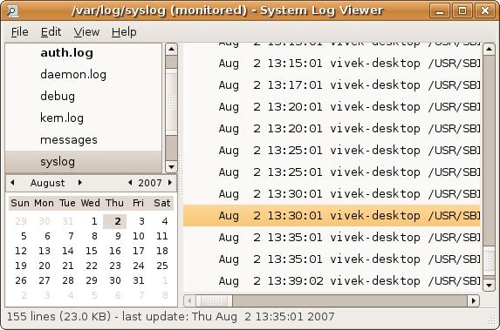](https://www.cyberciti.biz/faq/ubuntu-linux-gnome-system-log-viewer/)Fig.01 Gnome log file viewer

**A note about rsyslogd**

All of the above logs are generated using rsyslogd service. It is a system utility providing support for message logging. Support of both internet and unix domain sockets enables this utility to support both local and remote logging. You can view its config file by tying the following command:  
# vi /etc/rsyslog.conf  
# ls /etc/rsyslog.d/  
In short /var/log is the location where you should find all Linux logs file. However, some applications such as httpd have a directory within /var/log/ for their own log files. You can rotate log file using [logrotate](https://www.cyberciti.biz/faq/how-do-i-rotate-log-files/) software and monitor logs files using [logwatch](http://nixcraft.com/linux-software/477-howto-linux-monitor-logfiles.html) software.